# Lab Task 3

### Filter 1

### (ip.addr == 192.168.10.3)

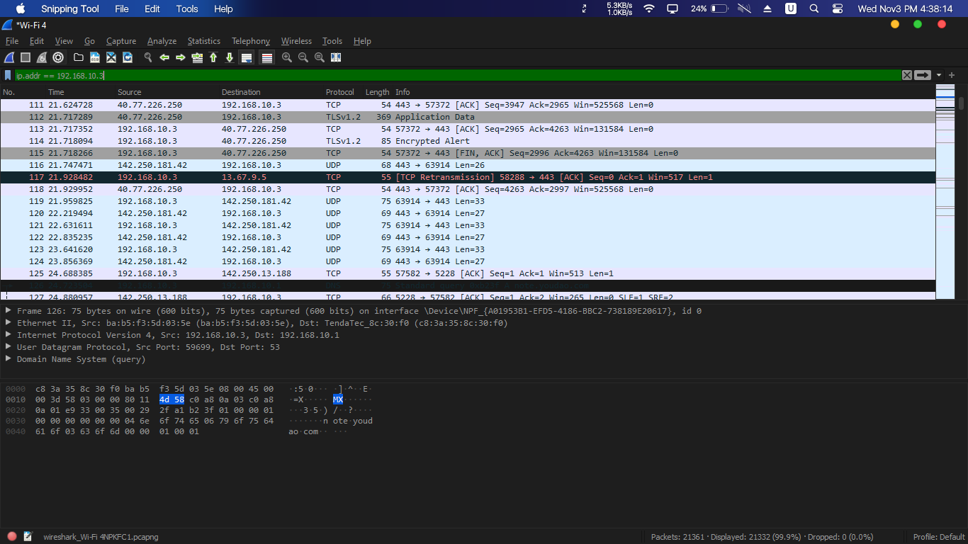

### Filter 2

### (ip.src == 192.168.10.3)

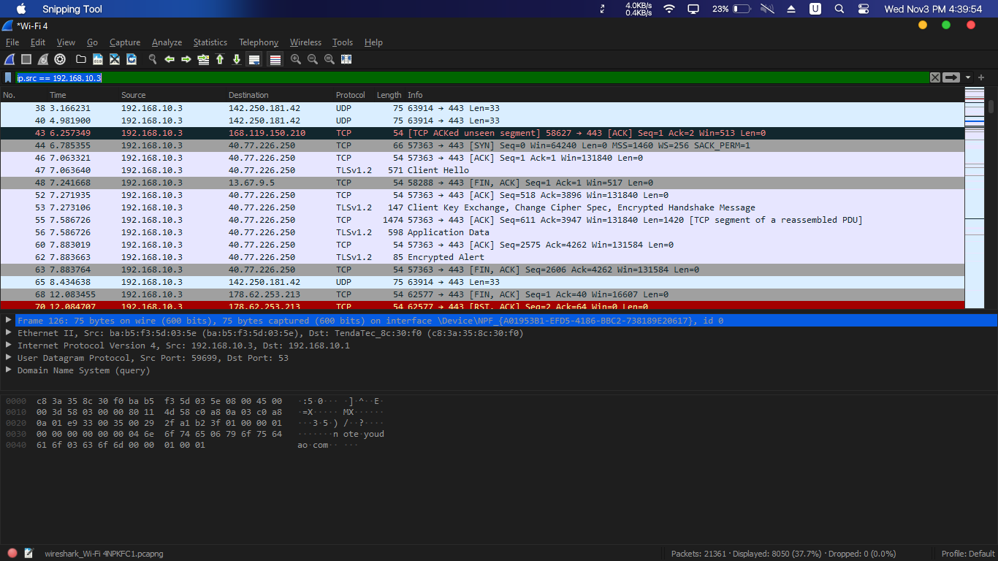

### Filter 3

### (ip.dst==192.168.10.3)

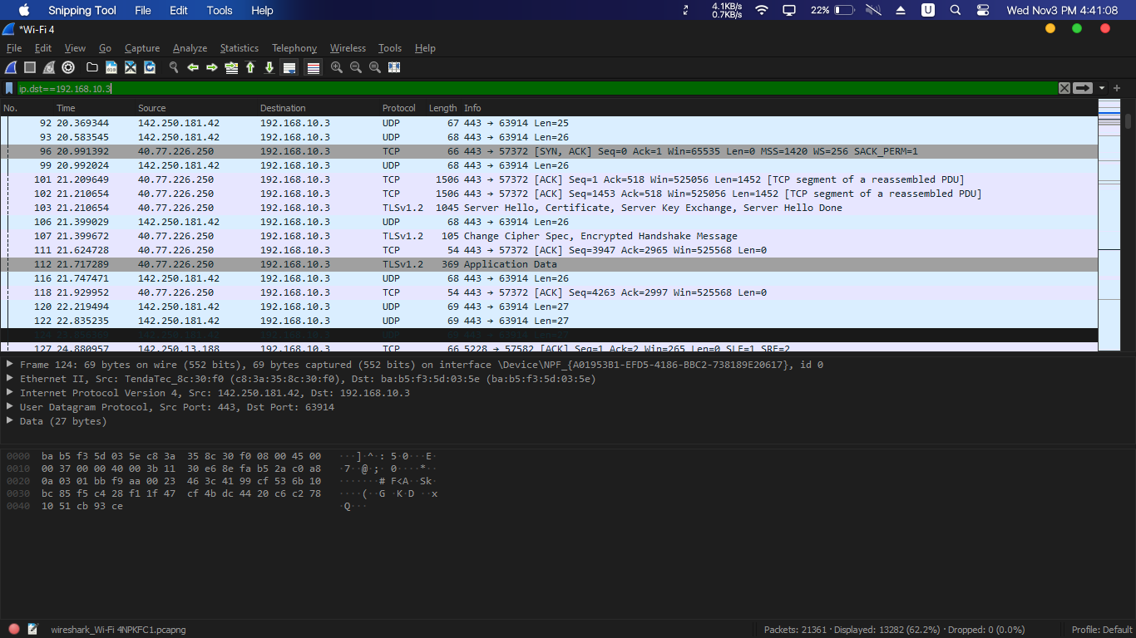

### Filter 4

### (ip.addr == 192.168.10.3/24)

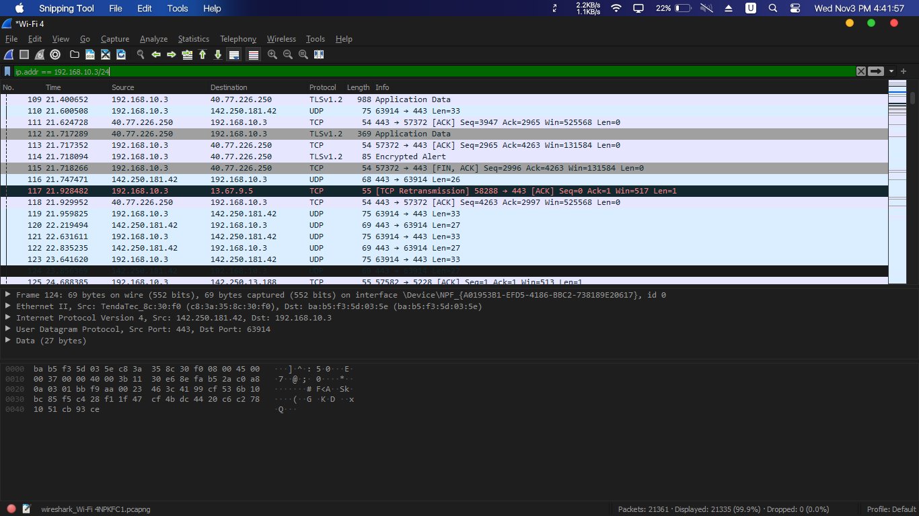

### Filter 5

### (dns)

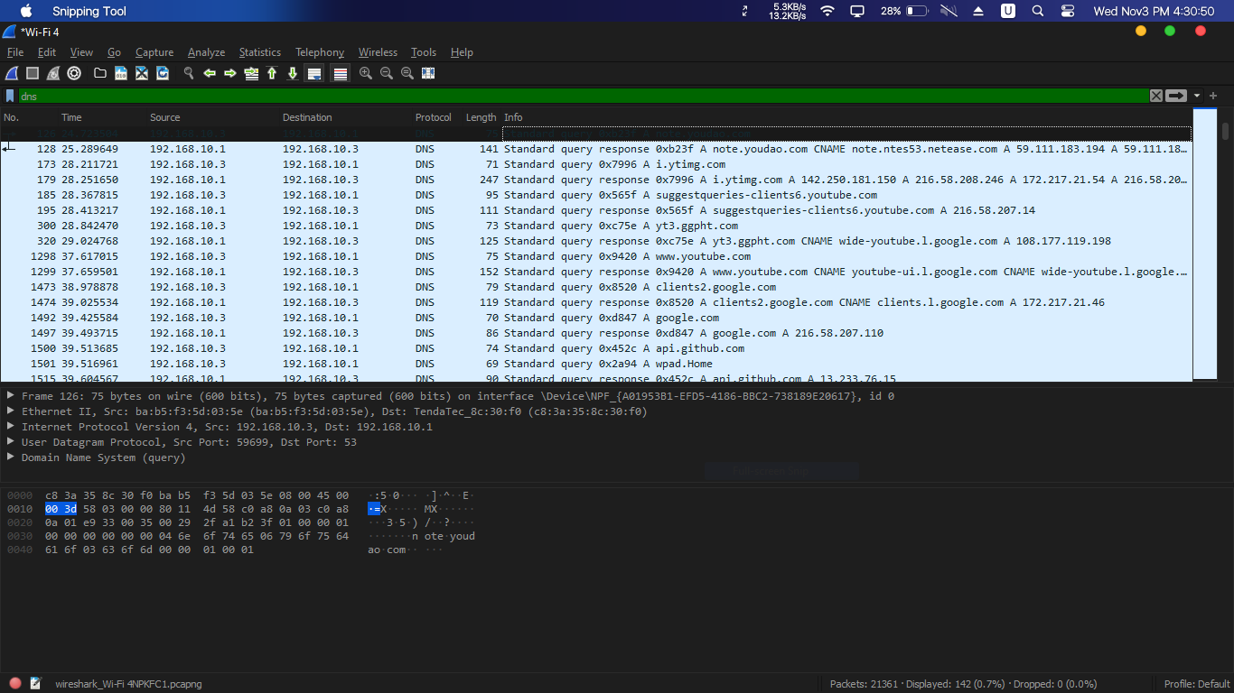

### Filter 6

### (!ip.addr==192.168.10.3)

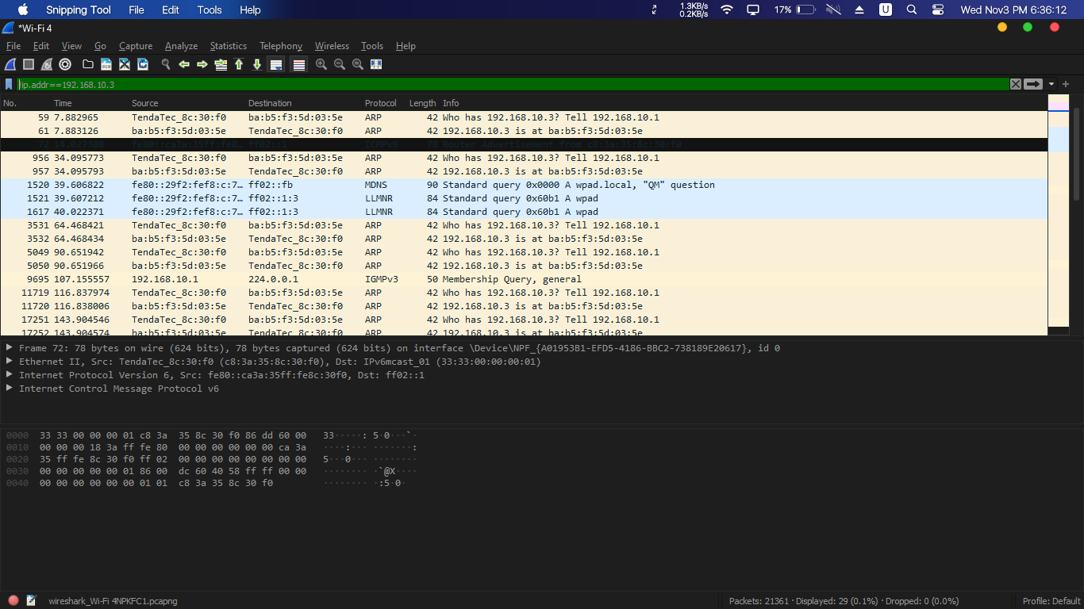

### Filter 7

### (ip.addr==192.168.10.3/24 and ip.addr==192.168.10.1/24)

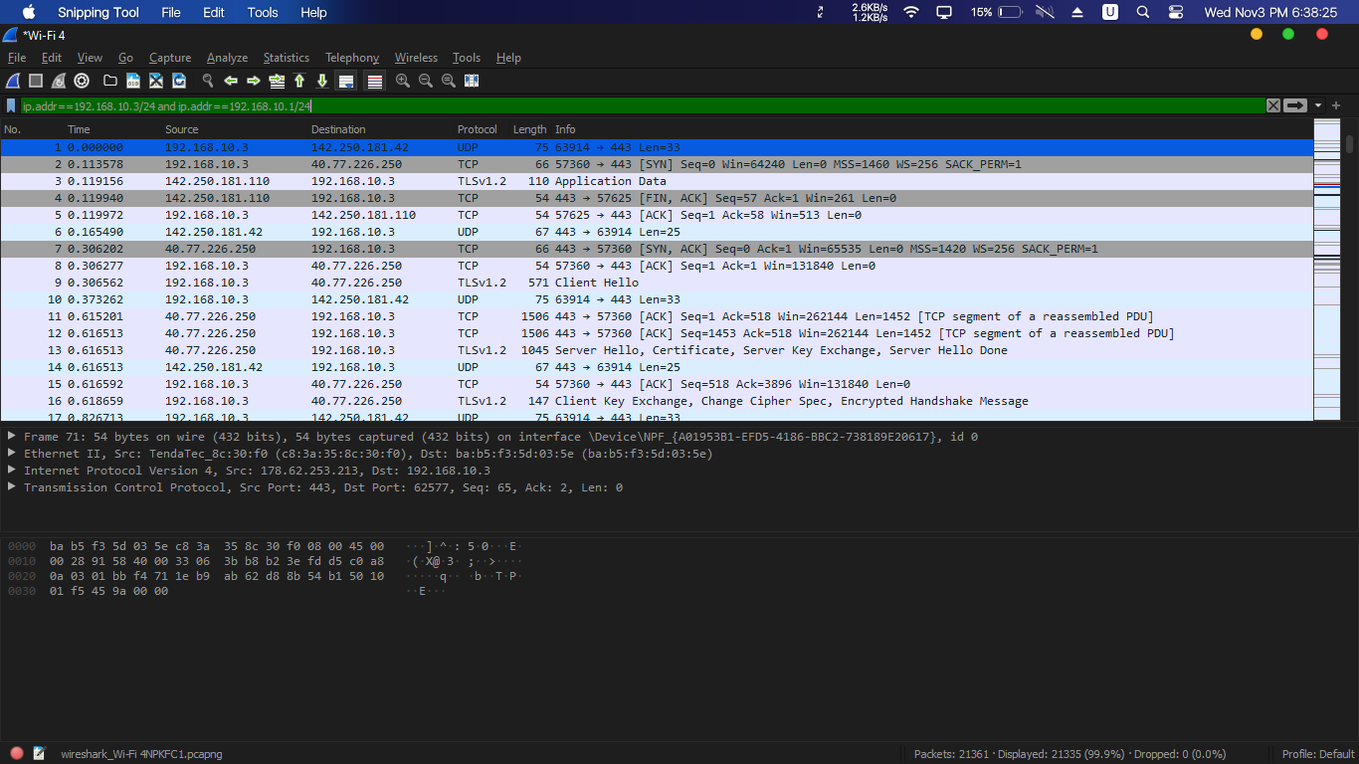

### (ip.addr==192.168.10.3 and ip.addr==192.168.10.1)

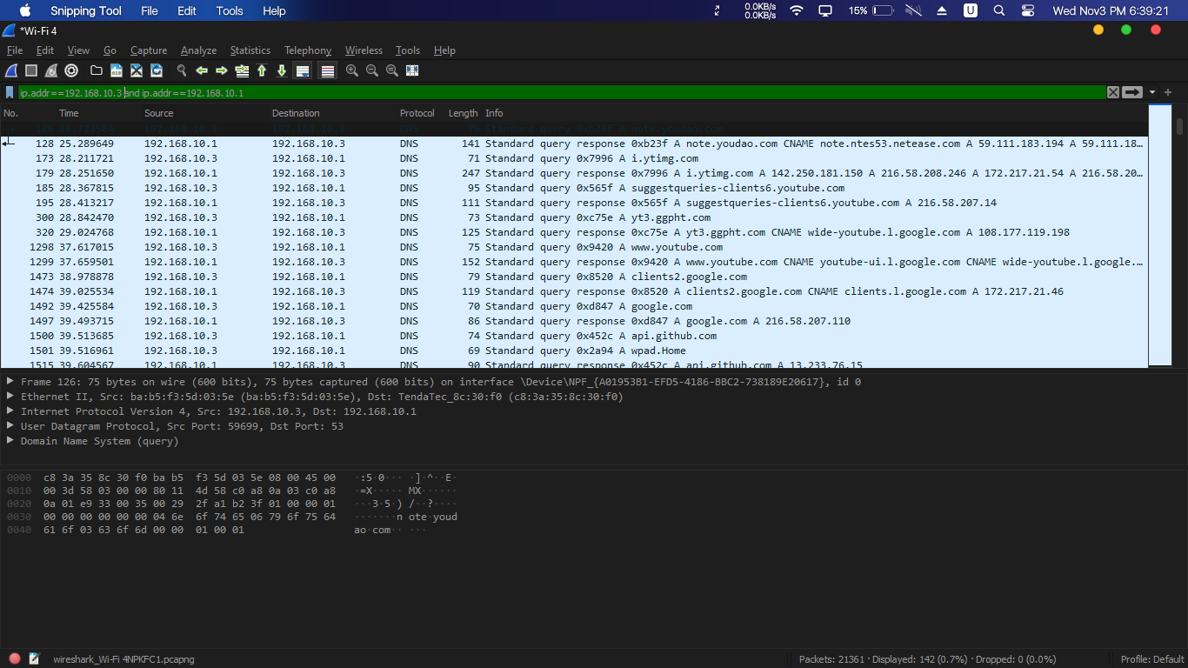

### Filter 8

### (eth.addr == BA-B5-F3-5D-03-5E)

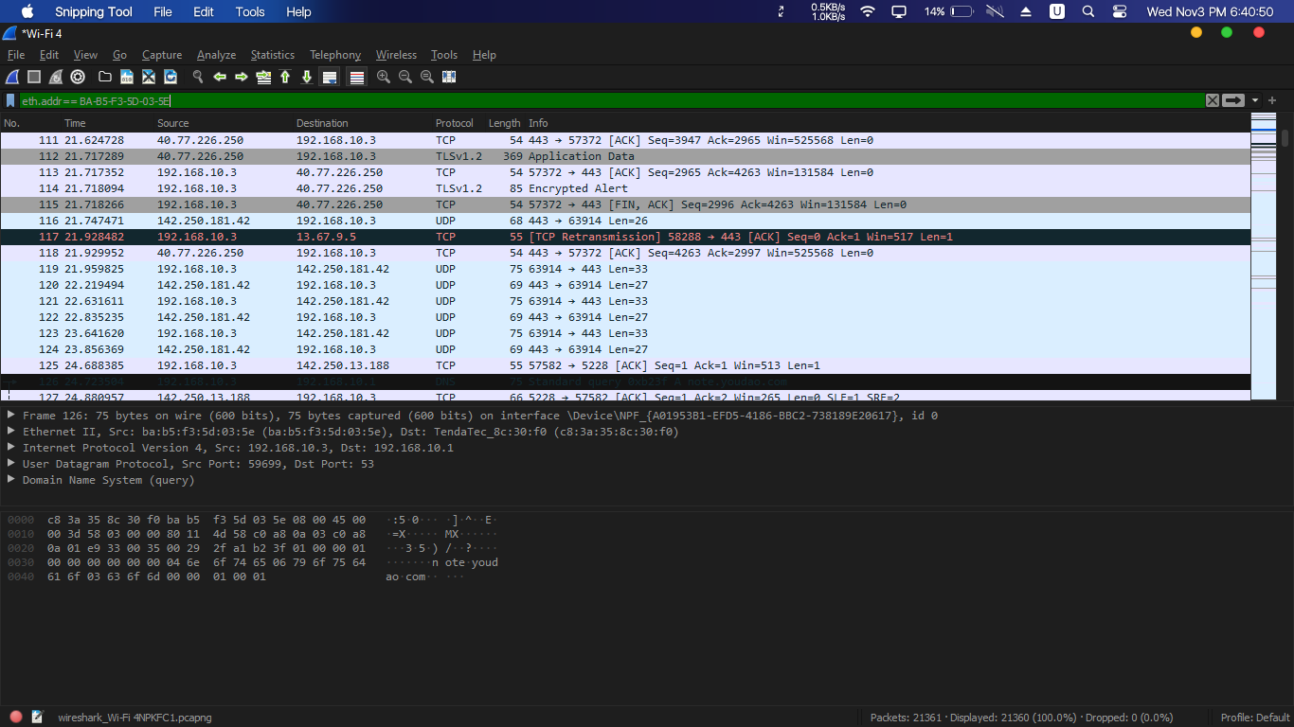

### Filter 9

### (tcp.port == 80)

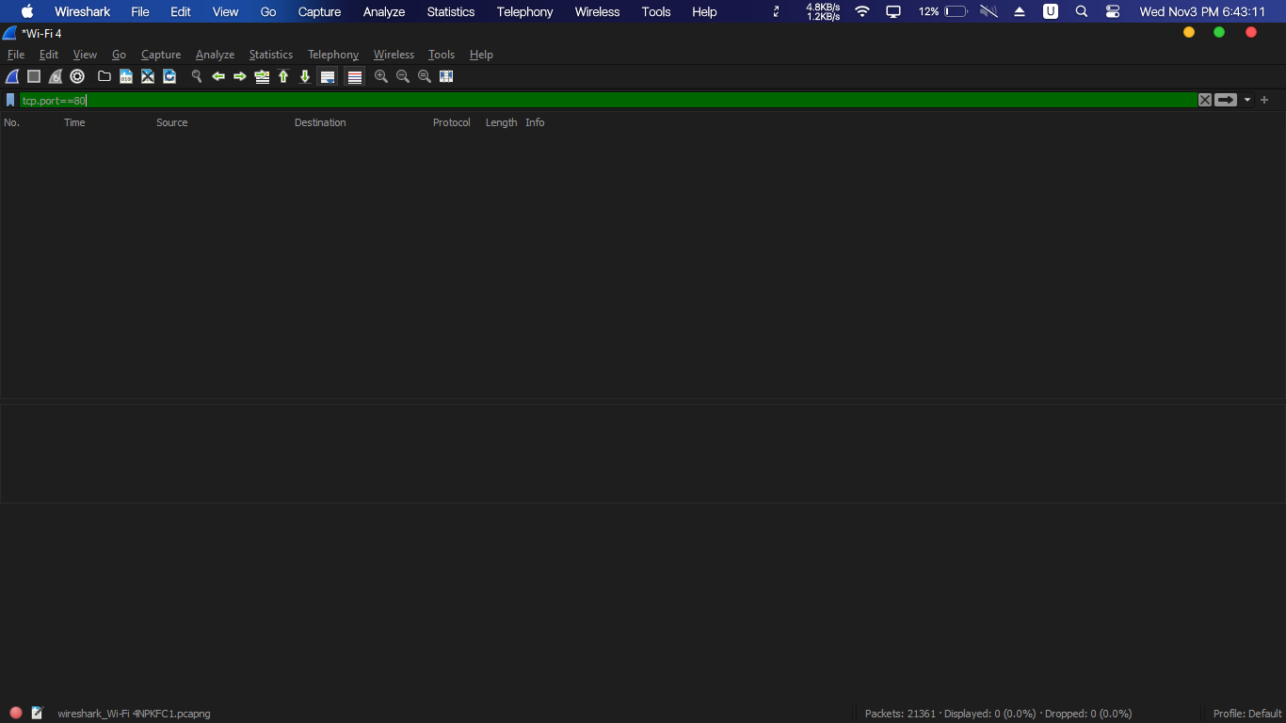

### (tcp.port==443)

### 

### (tcp.srcport == 80)

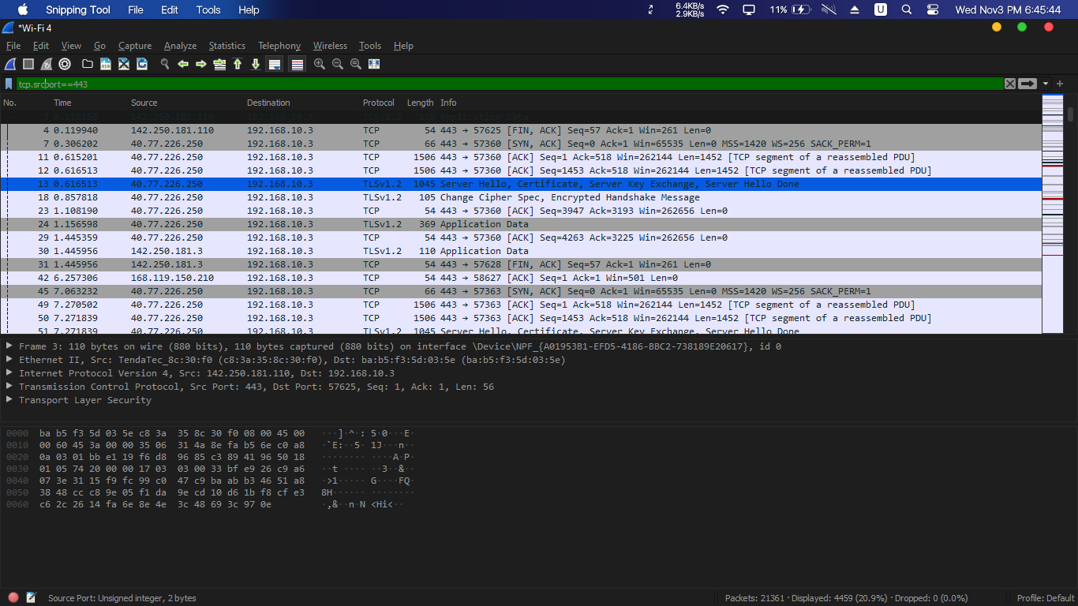

### (tcp.dstport == 80)

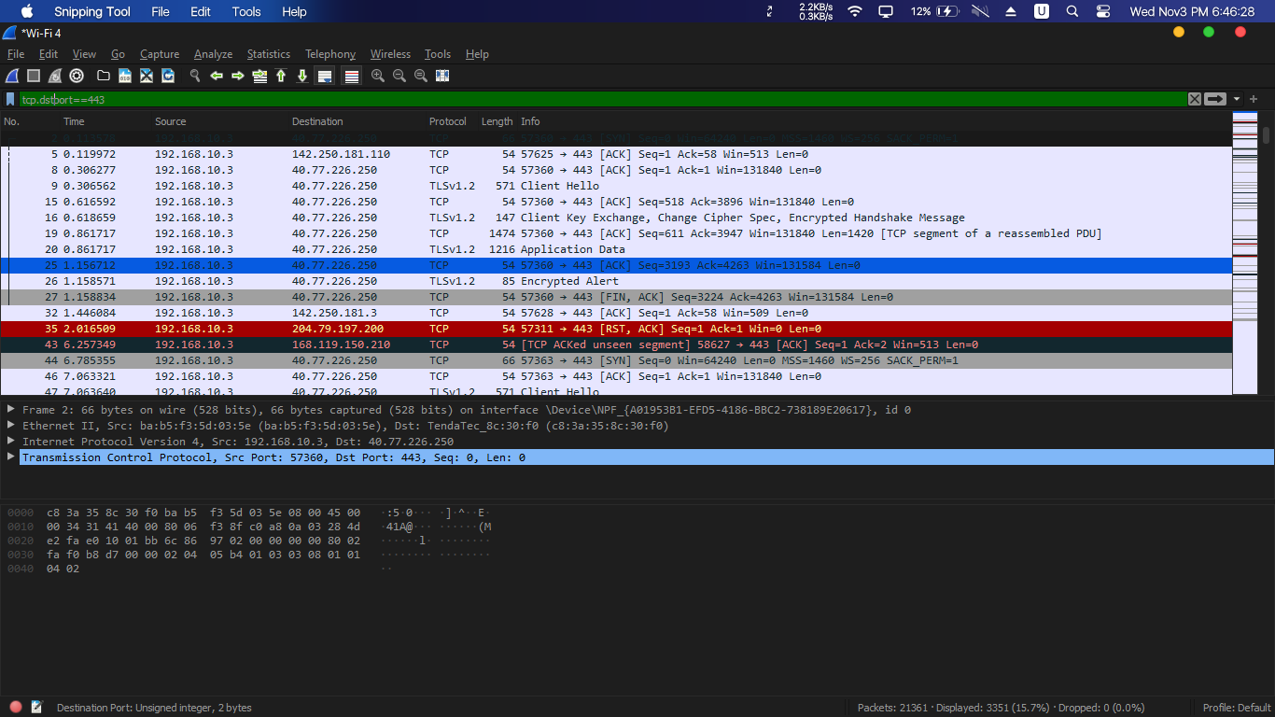

### Filter 10

### (http.user_agent contains Firefox)

### 

### (http.user_agent contains Firefox || http.user_agent contains Chrome)

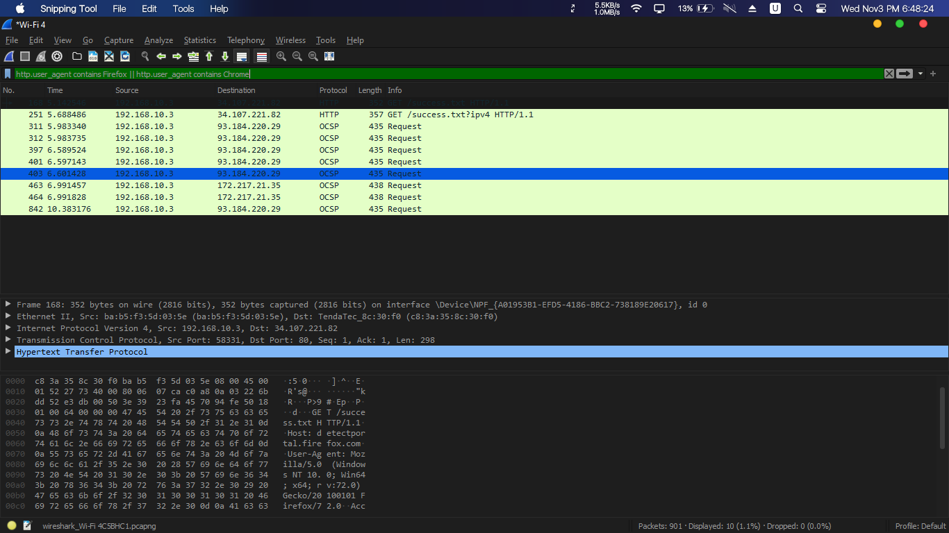

### Filter 11

### (tcp.port == 80 && ip.addr == 192.168.10.3)

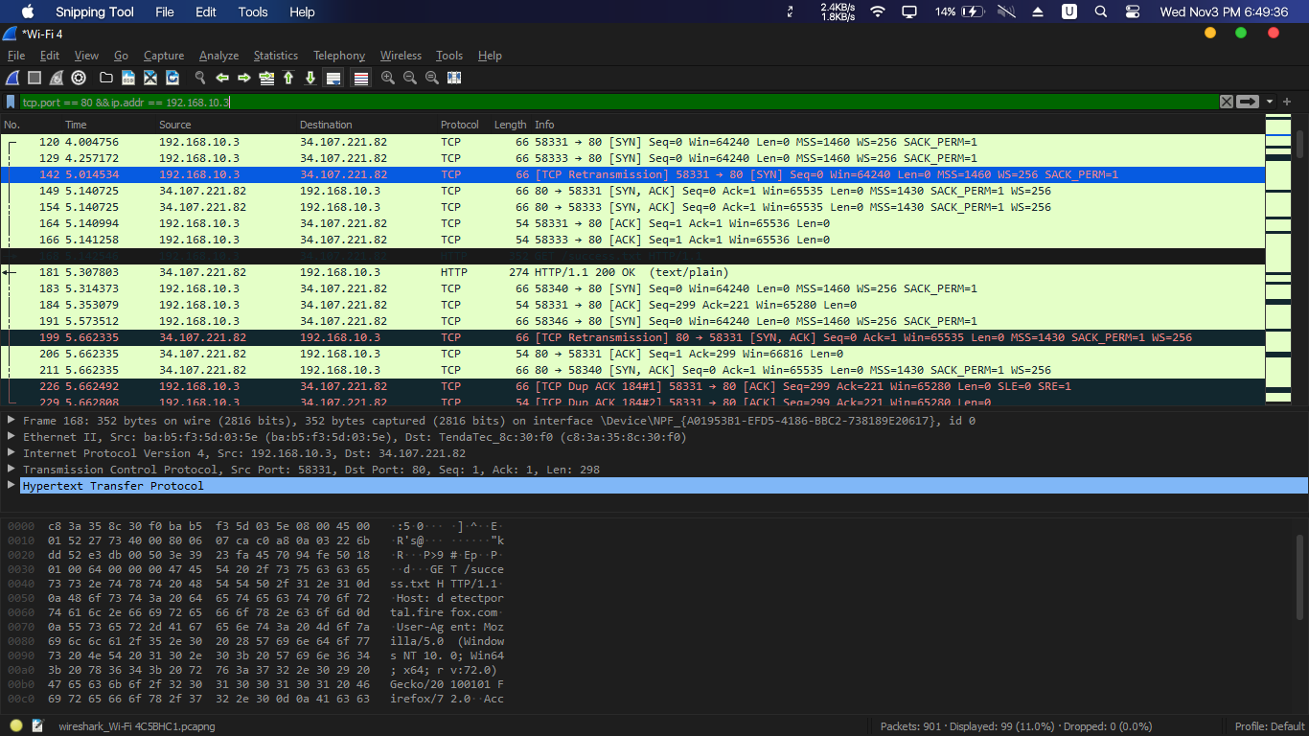

### Filter 12

### (http.request)

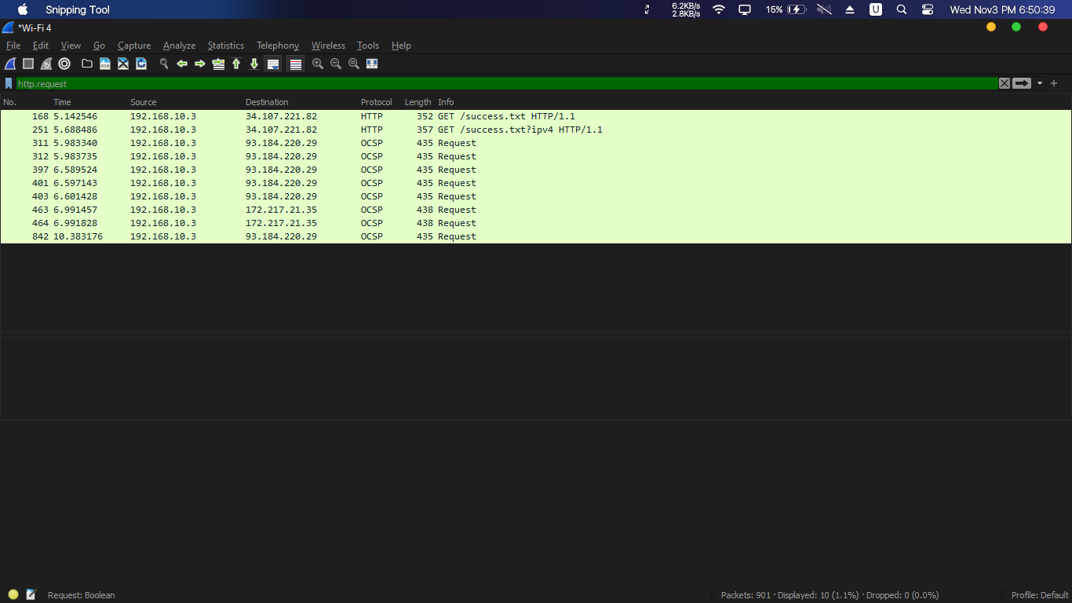

### Filter 13

### (http.request or http.reponse)

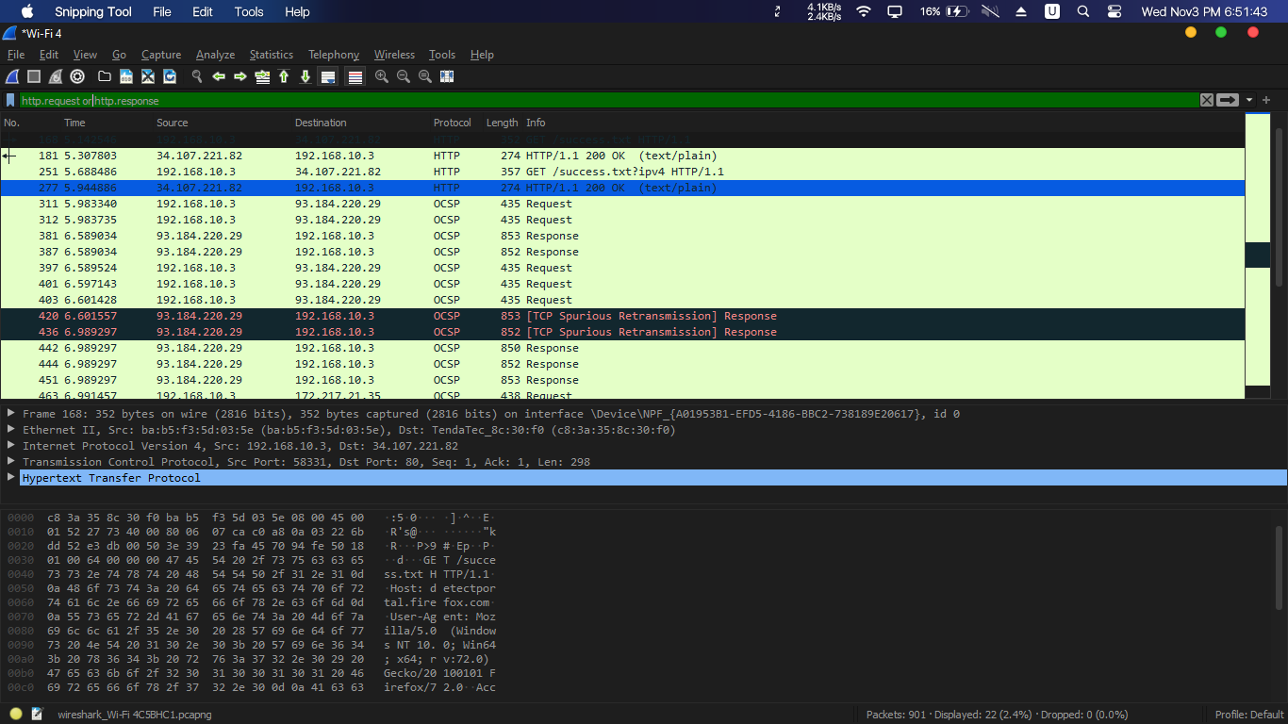

### Filter 14

### (frame contains "(attachment|tar|exe|zip|pdf)")

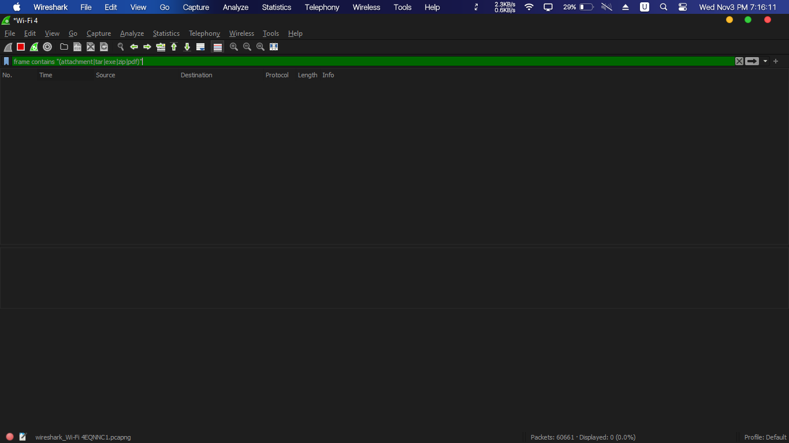

### Filter 15

### (tcp contains facebook)

